Easiest Native Plant Species for Santa Cruz County – Groundcovers

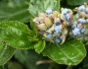
Ceanothus thyrsiflorus var. thyrsiflorus – Creeping Blueblossom
Grows well in many different soils and tolerates poor or fast draining situations. Great for erosion control. Wide spread – up to 15’.
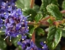
Ceanothus thyrsiflorus var. griseus – Carmel Creeper
Fast and easy. One of the most commonly planted groundcovers in California. Can also spread up to 15’.
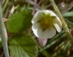
Fragaria chiloensis – Beach strawberry
Beautiful dark glossy leaves, it is the parent of commercial strawberries whose genes provide vigor. Prefers sandy soils.
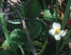
Fragaria vesca – Wood strawberry
Can quickly cover an area. Good under trees, tasty fruit. Easy-care.

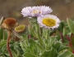
Erigeron glaucus – Seaside daisy
Loves our coastal climate, very showy, in bloom almost all year, deer resistant. Up to 2’ spread.
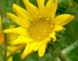
Grindelia stricta – Gumplant
Long-flowering, can spread 6-10’, takes salt spray and supports a wide diversity of bees. Deer resistant. Used to treat poison oak and as an adhesive.
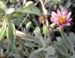
Corethrogyne filangifolia – California aster
Formerly called Lessingia filangifolia, a long-flowering butterfly plant that prefers well-drained soils. Silvery foliage, light purple to pink flowers.
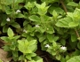
Clinopodium douglasii – Yerba Buena (good herb)
A low trailing plant with dainty oval mint-scented leaves. Edible and makes a great tea. For woodland gardens.
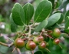
Arctostaphylos hookeri ssp. hearstiorum and Monterey Carpet– Hooker’s manzanita. Rare, threatened or endangered in the wild.
These 2 subspecies are very low growing approx. 1 ft tall X 6 ft wide

